Lab: Unprotected admin functionality

Open the burpsuite and turn on the intercept in the proxy. Append the value /robots.txt to the url and forward the value to the repeater and we get the path to the admin panel that is /adminstrator-panel. Now append this value the actual url and you will be able to delete the user carlos.

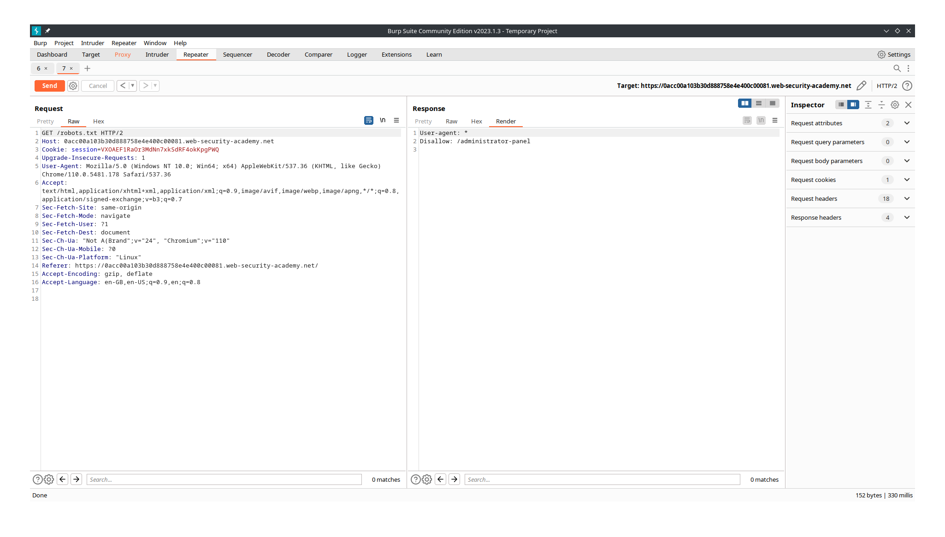

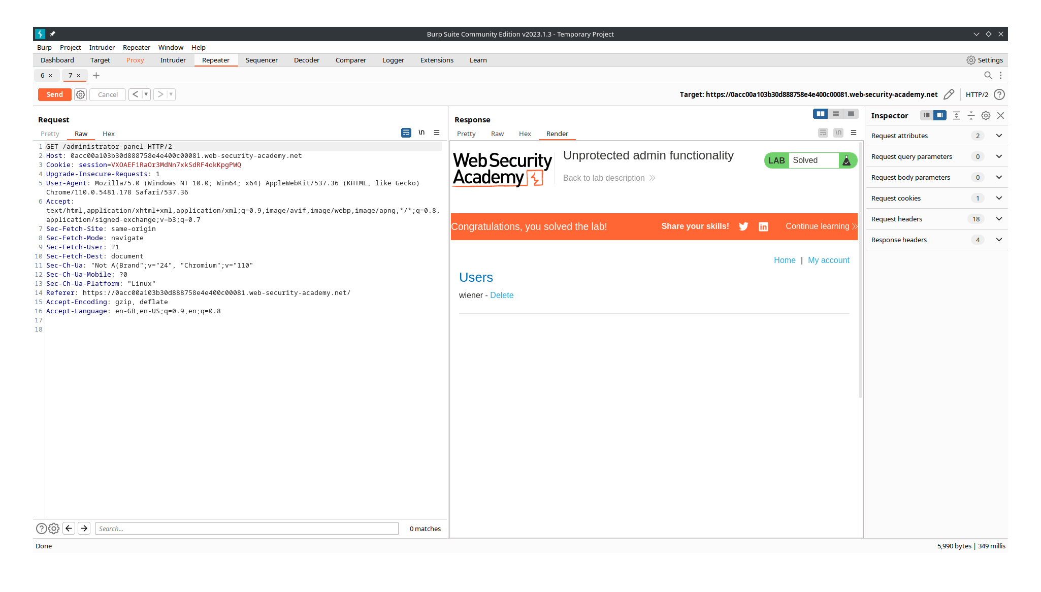

Lab: Unprotected admin functionality with unpredictable URL

Open the burpsuite and turn on the intercept in the proxy. Append the value /robots.txt to the url and forward the value to the repeater and this it doesn’t work. So try checking the javascript source code of the page to get to the admin functionality. There you can get the value /admin-xy27cm. Now append this value the actual url and send forward this traffic to the repeater and you will be able to delete the user carlos.

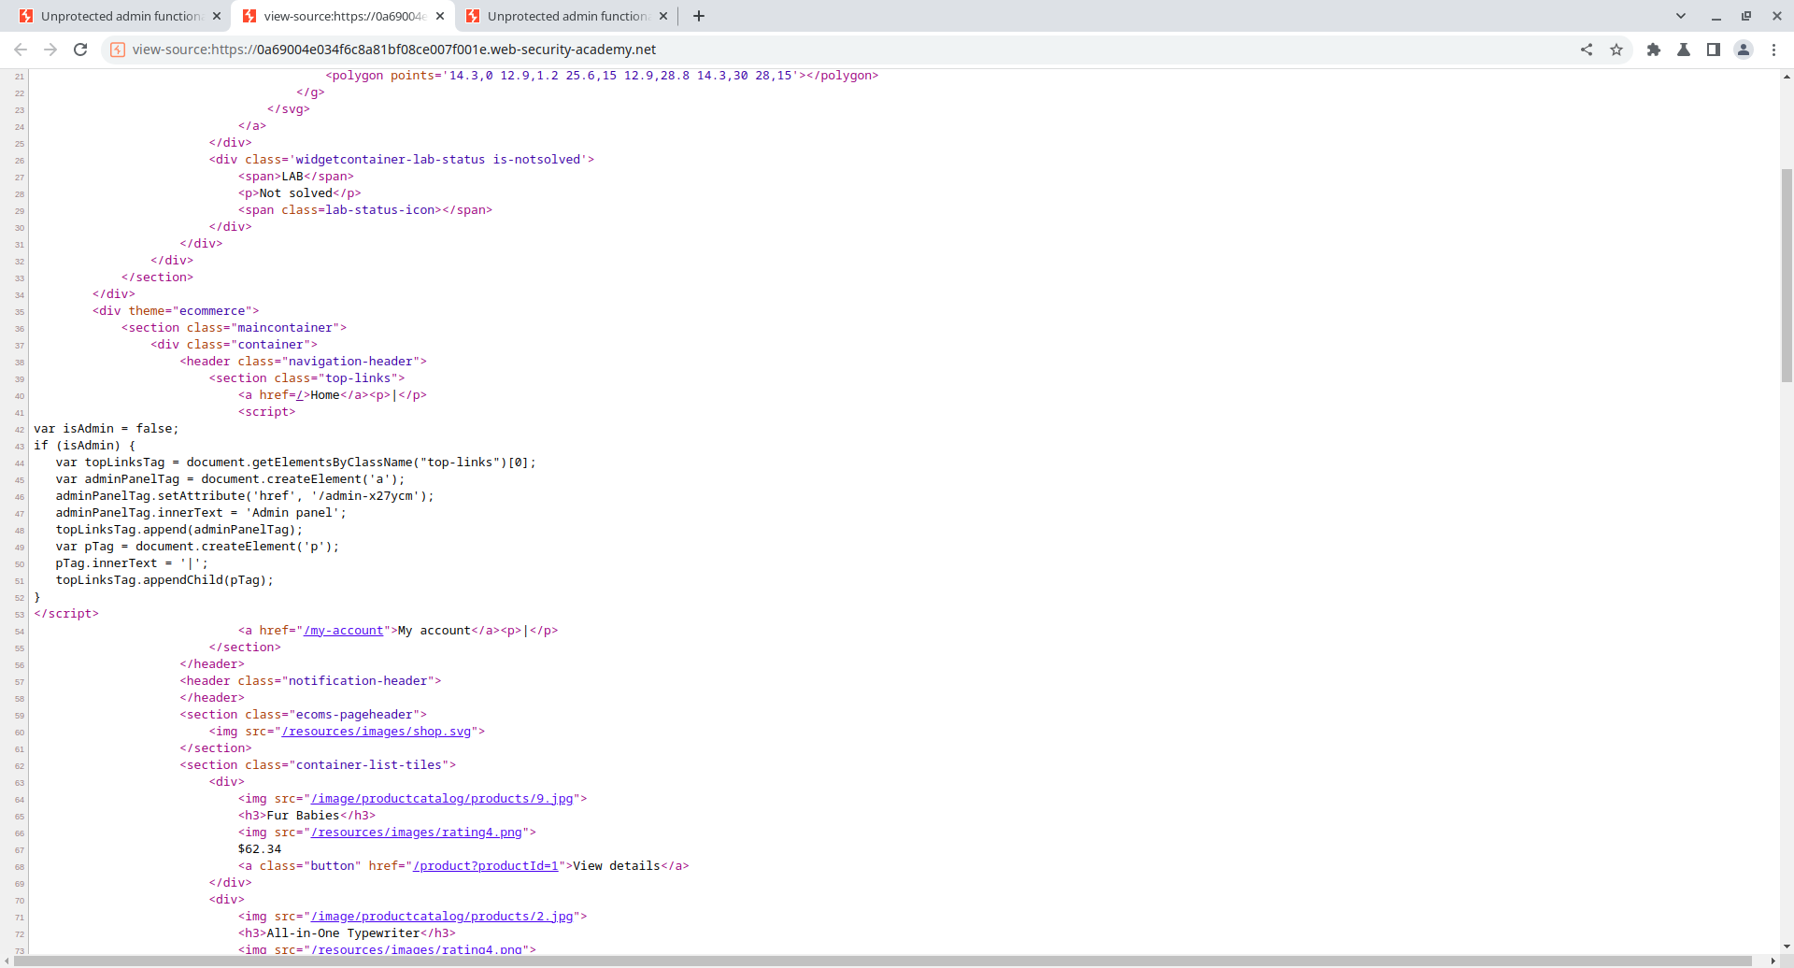

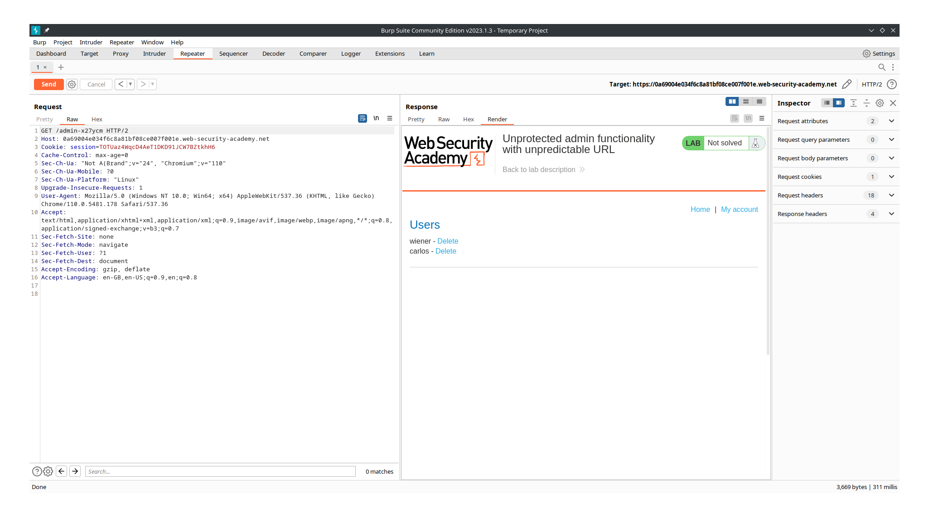

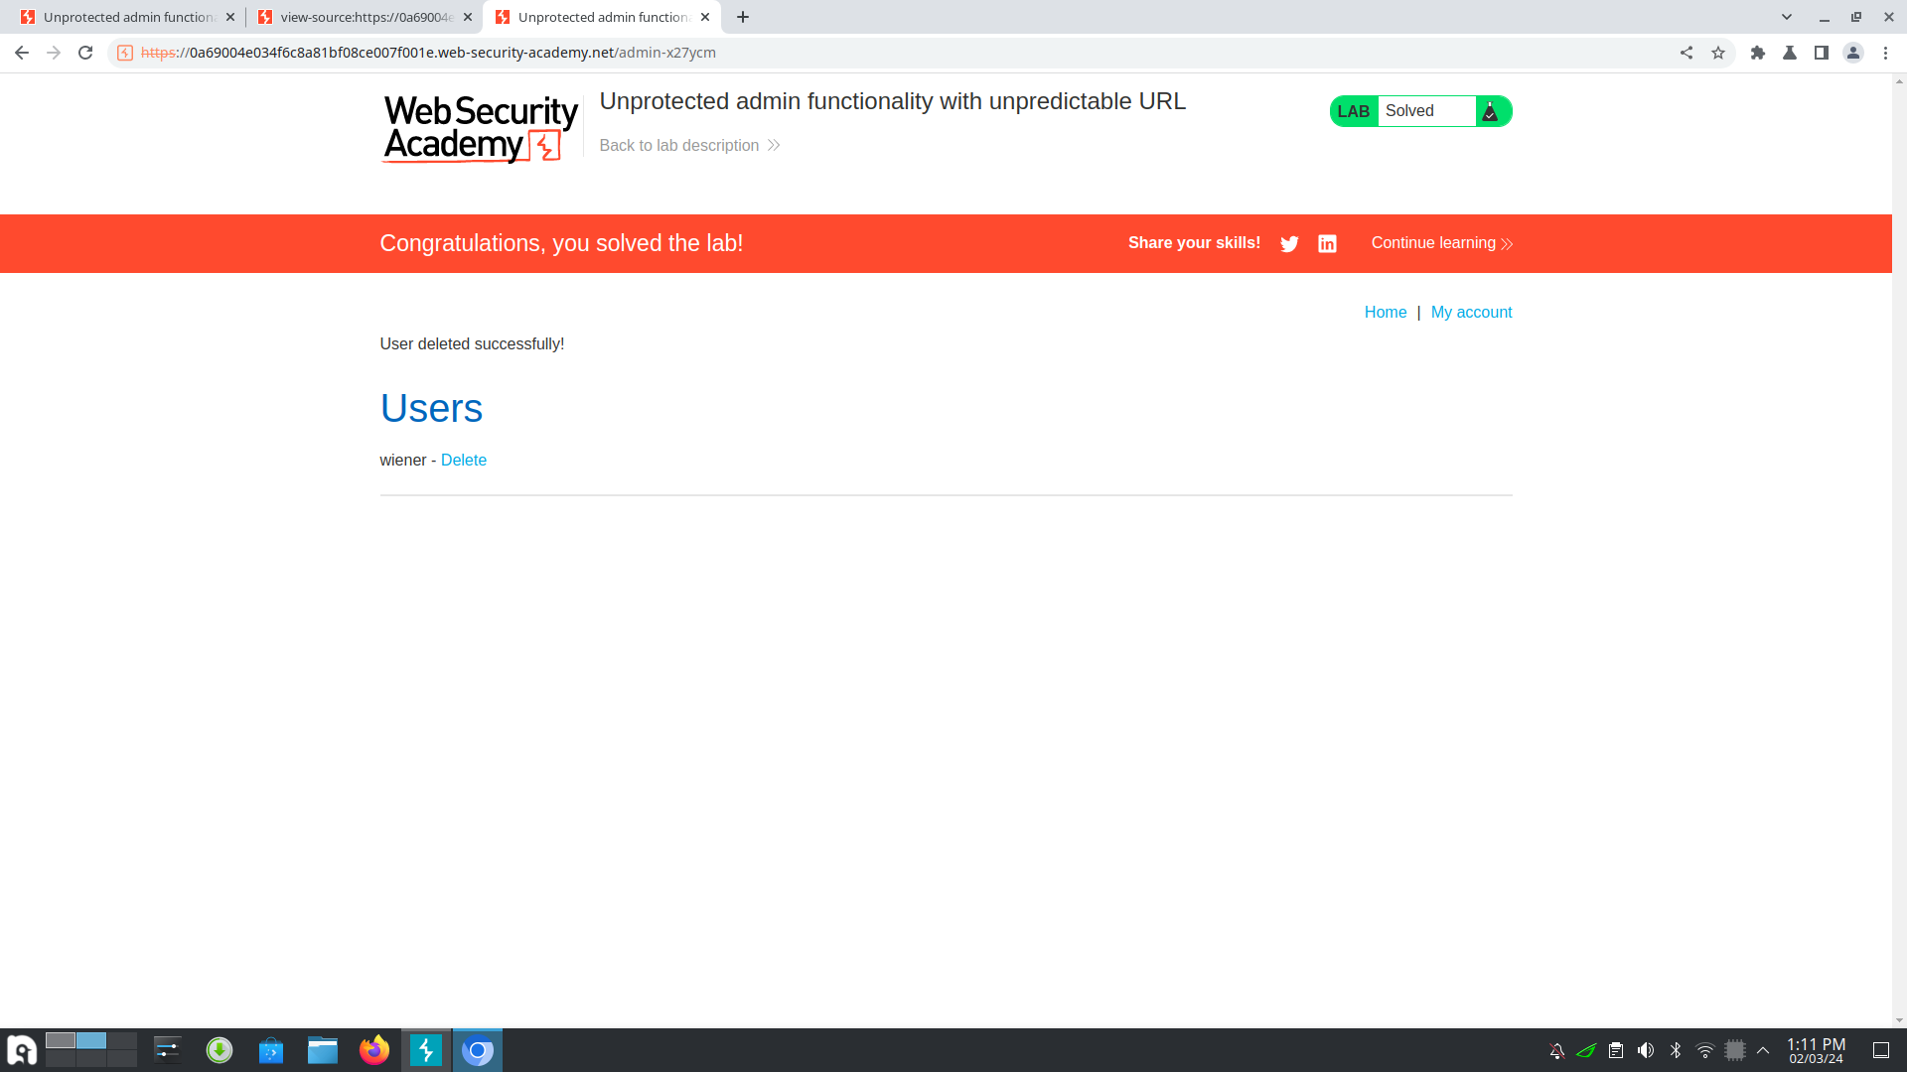

Lab: User role controlled by request parameter

Open the burpsuite and turn on the intercept in the proxy. Login in with the given credentials and check the request in the target tab. Now forward the my-account request to the repeater and change the id to wiener. Send the modified request and the admin panel will be displayed and now you will be able to delete the user carlos.

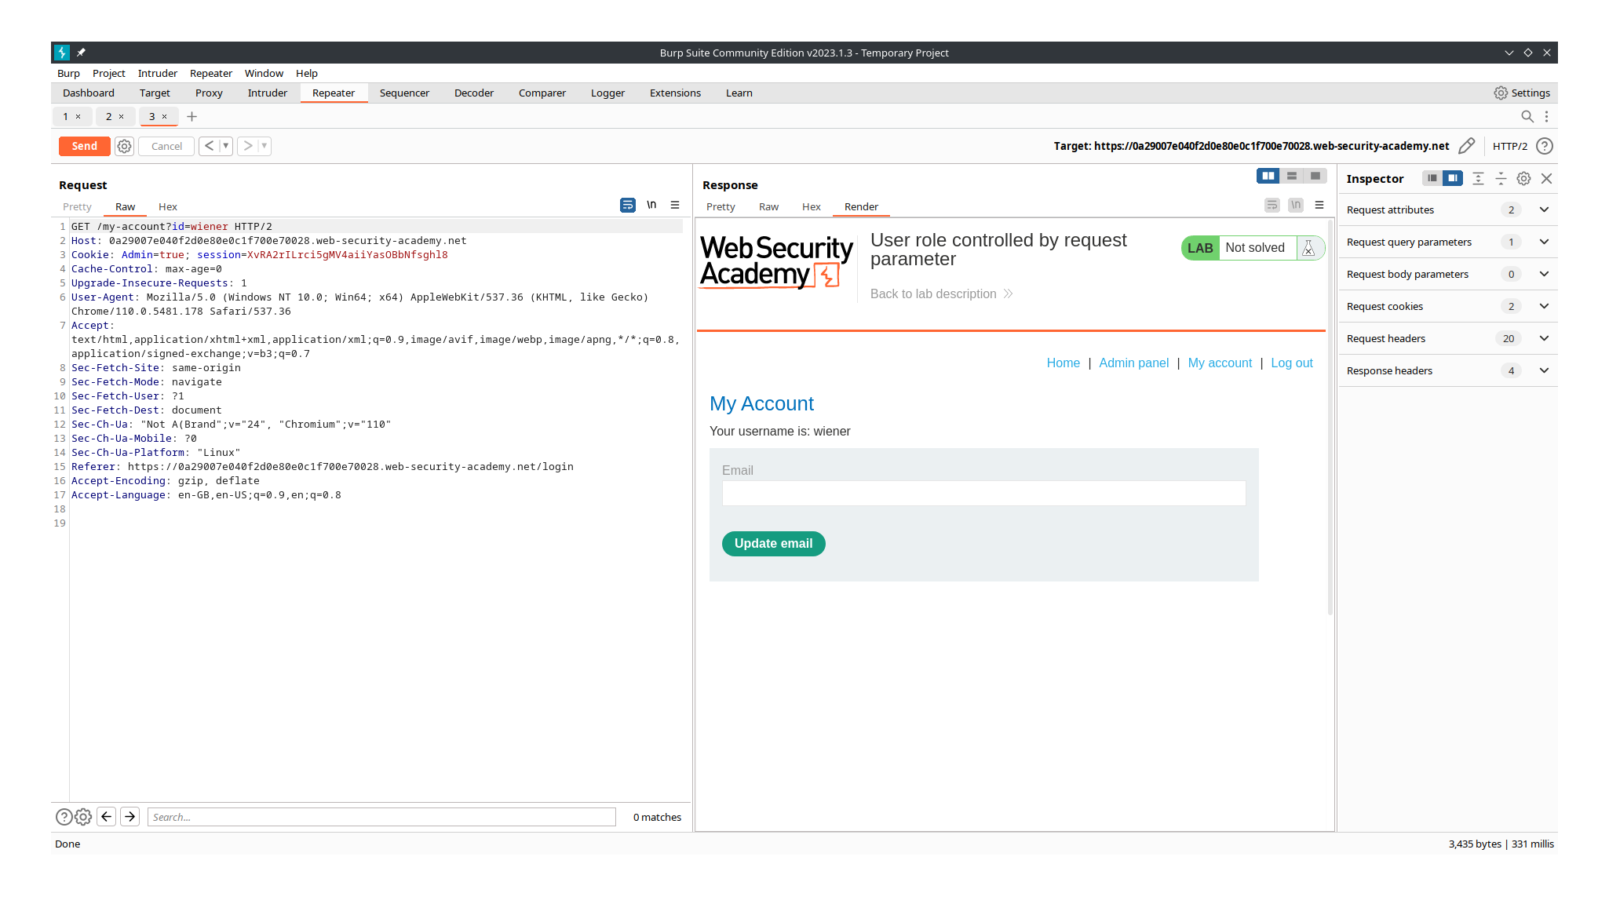
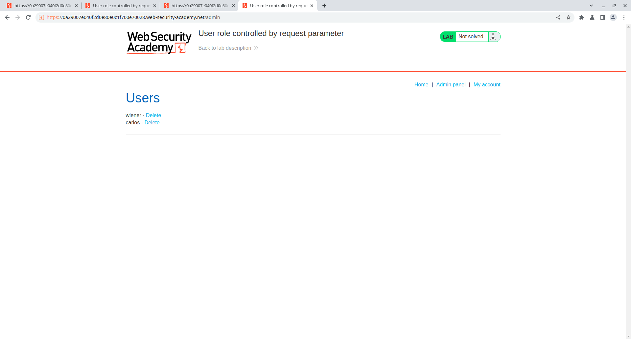

Lab: User ID controlled by request parameter, with unpredictable user Ids

Open the burpsuite and turn on the intercept in the proxy. Check for any post by the user carlos so that we can manage to get the id of him. Click a post by him and store request to fetch his id. Now login with the given credentials and forward this request to the repeater. We can change the value of the id from the id that we identified from carlos post request. Send the modified request and the admin panel will be displayed and now you will be able to delete the user carlos.

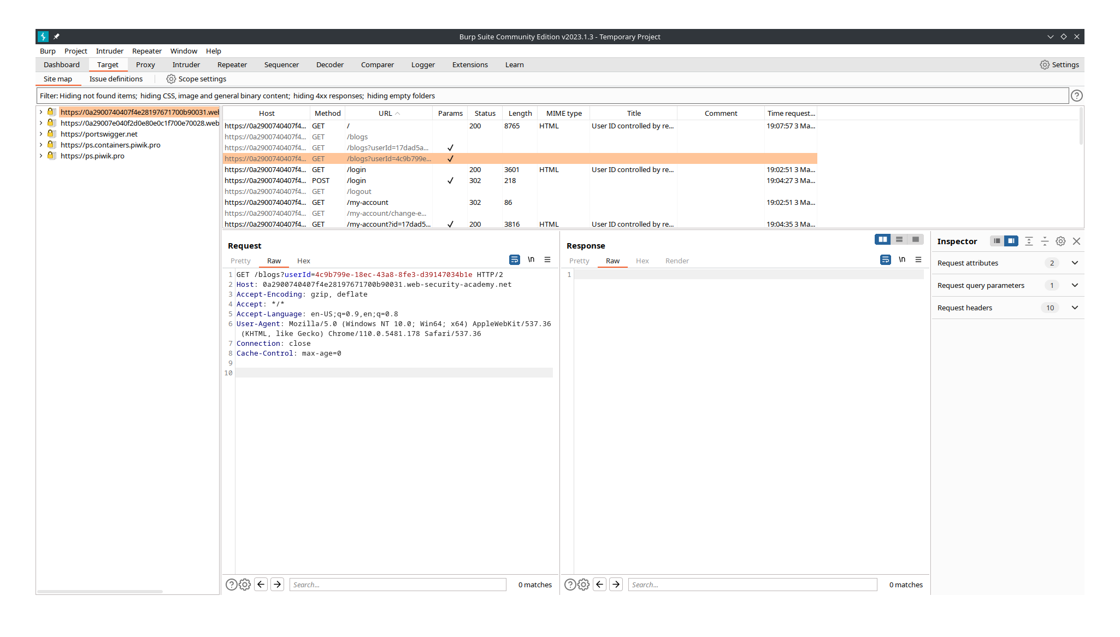

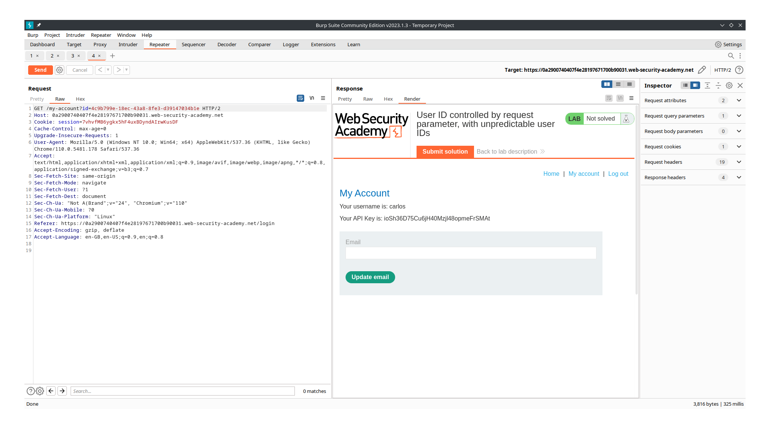

Lab: User ID controlled by request parameter with password disclosureReact js gen_key func

Open the burpsuite and turn on the intercept in the proxy. Login in the given credentials and you will have your password store in the my account section. Forward this request to repeater and modify the id to administrator. Send the modified request and the admin panel will be displayed and now you will be able to delete the user carlos.

